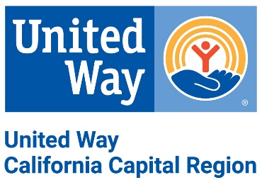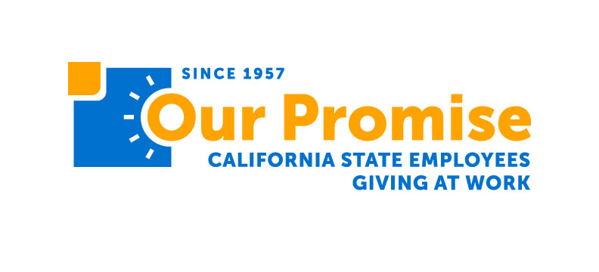

Nonprofit Giving Toolkit
Fall 2022

Workplace Giving DETAILS
Workplace Giving Campaigns are a FREE tool companies can use to engage with their employees and demonstrate a commitment to improving lives in the community. Together, United Way and Our Promise manage more than 250 campaigns of all sizes, in numerous industries throughout the Capital Region. With the help of a dedicated representative, companies and employees are connected directly to local nonprofits to inspire giving.

Sample Newsletter blurb (Promote September – december)
Use a compelling image of your nonprofit in action.
Subject: Give to Us Through Your Workplace Giving Campaign
Did you know that we partner with United Way California Capital Region and Our Promise California State Employees Giving at Work to ensure we have the critical components need to carry out our nonprofit’s mission effectively?

If you work for the State of California or at one of more than 250 local companies like SMUD, Target or Nationwide, you can choose to give a portion of your paycheck to help us [insert mission]. This provides us with a consistent cash flow and we’re able to check payouts, donor details and more, taking the administrative burden off us. Plus, companies sometimes offer matching funds – helping your dollars make an even bigger impact.

Consider giving to [insert nonprofit name] through your workplace giving campaign today.

Sample Social Media Posts
Spread the word through your social media & be sure to tag us @OurPromiseCA and @UnitedWayCCR, so we can amplify your message through our networks.

SUBJECT | MESSAGE | PHOTO
Workplace Giving | Do you work for the State of California or at one of more than 250 local companies like SMUD, Target or Nationwide? Give to us through payroll deduction to help us [insert mission]. | Use compelling images/videos of your nonprofit in action
Fun: October | It may be #SpookySeason, but the only thing we’re trying to be scared by is how scary-generous employees are! 👻  Get in on the action and make a gift to [insert nonprofit] name] during your workplace giving campaign.  [Link to website] | Use compelling images/videos of your nonprofit in action
Fun: November | Feeling extra thankful this time of year? 🍂  Pay it forward and donate to [insert nonprofit name] through your workplace giving campaign.  [Link to website] | Use compelling images/videos of your nonprofit in action
Fun: December | ‘Tis the season for giving! 🎁  Avoid a lump of coal by donating to [insert nonprofit name] through your workplace giving campaign before it’s too late!  [Link to website] | Use compelling images/videos of your nonprofit in action

additional Resources
United Way and Our Promise works directly with companies and state departments to connect employees with local nonprofits to inspire giving and hear directly about the impact their dollars are making for the causes they choose to support. The Nonprofit Outreach Program offers two services:
- Speaking Engagements: Trained nonprofit speakers can join a meeting in person, virtually or provide a previously recorded video to share their nonprofit’s mission, programs and impact directly with employees.
- Nonprofit Fairs: Multiple nonprofits can join an event in person, virtually or provide a previously recorded video so employees can learn about multiple nonprofits and programs at once.
For more information, contact Jolissa Lamb at jolissa.lamb@uwccr.org.

Important Campaign links
- United Way California Capital Region Website: https://www.yourlocalunitedway.org
- Our Promise Website: www.ourpromiseca.org
- United Way Nonprofit Directory (new & improved!): https://www.yourlocalunitedway.org/partnerships/nonprofits/directory-of-certified-nonprofits
- Our Promise Nonprofit Directory: https://www.ourpromiseca.org/find-nonprofit

